Hi! These are instructions to help prepare you for the Intro To Git Workshop.

First you’ll need to download git [here](https://git-scm.com/downloads).

Secondly you’ll need to download Visual Studio Code [here](https://code.visualstudio.com/download).

Third, you’ll want to make a github account [here](https://github.com/signup?ref_cta=Sign+up&ref_loc=header+logged+out&ref_page=%2F&source=header-home).

Please remember the email you signed up with, the first command we learn will depend on it!

Now lastly download the starter code I am providing and ensure you have the correct folder structure.

Download the 3 files provided in the [Intro To Git Folder](https://drive.google.com/drive/folders/1qY-7rSC-_hMU-e3yynGxkh324tM2k8kW?usp=sharing):

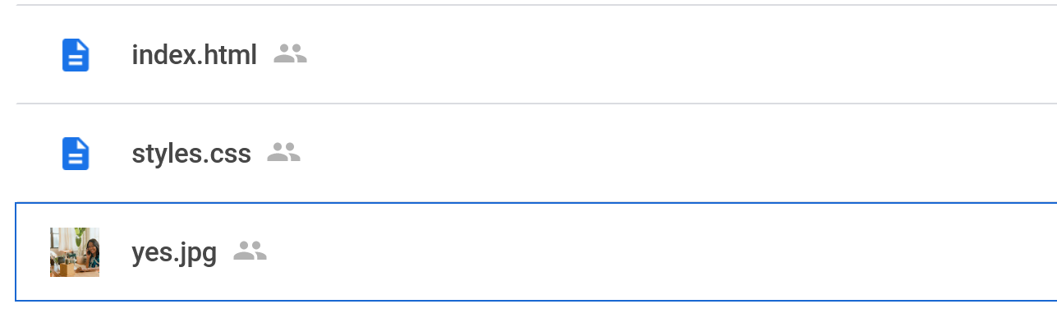

Now create a folder titled IntroToGit with no spaces in the title. Place all 3 files here. When we begin the workshop you will need to access this location so please put it somewhere you can find it!

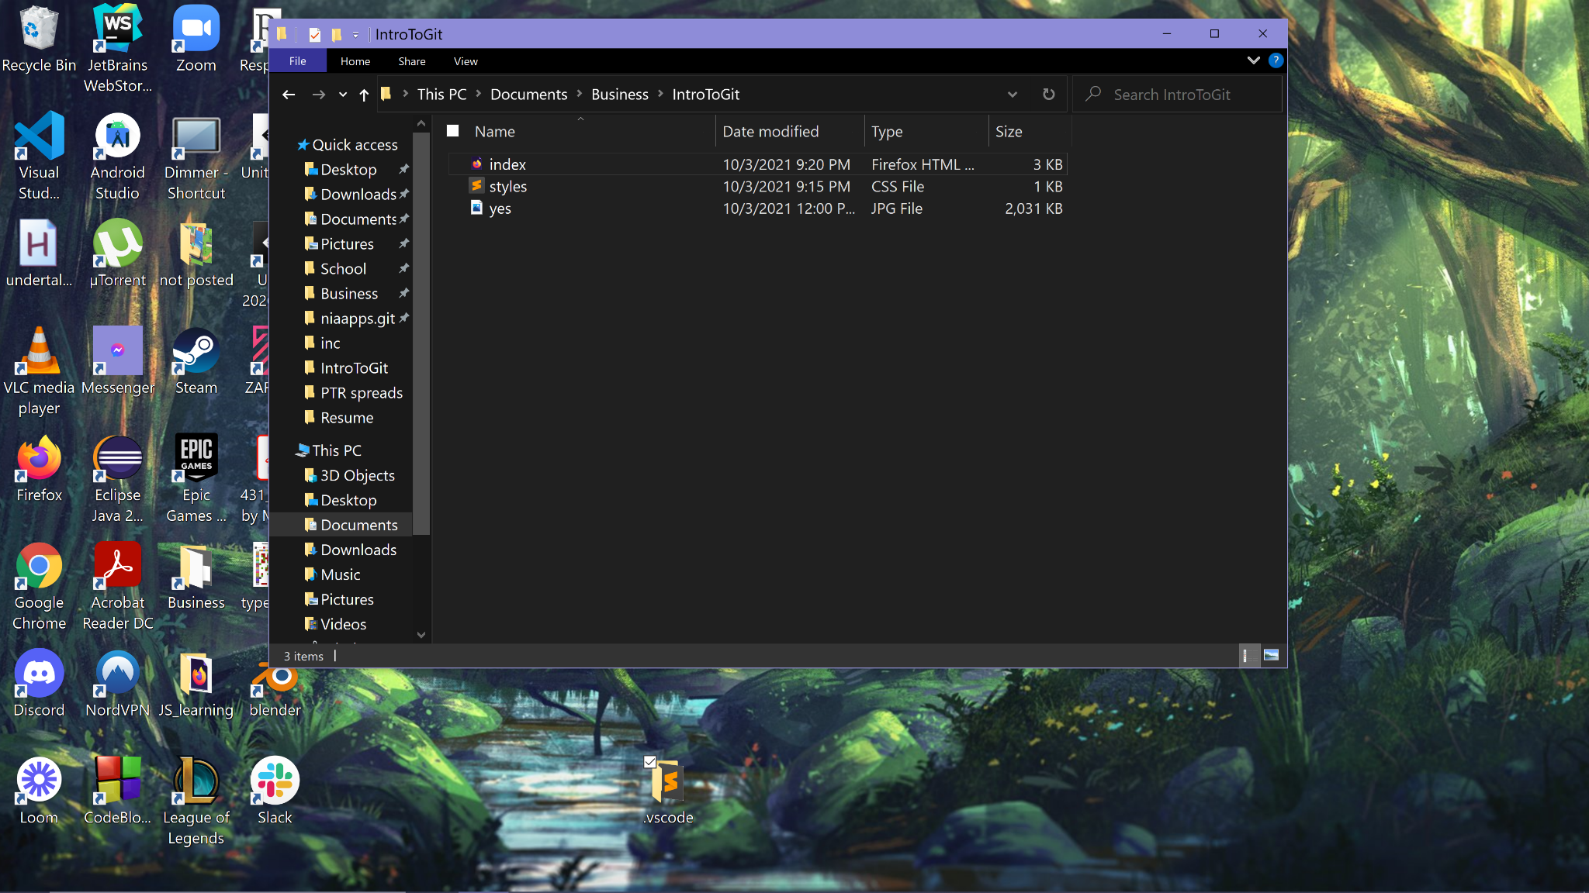

Now Open VsCode and go to File>Open Folder>Navigate to just inside your IntroToGit Folder(like the screenshot above) and select Open Folder

It should look something like this:

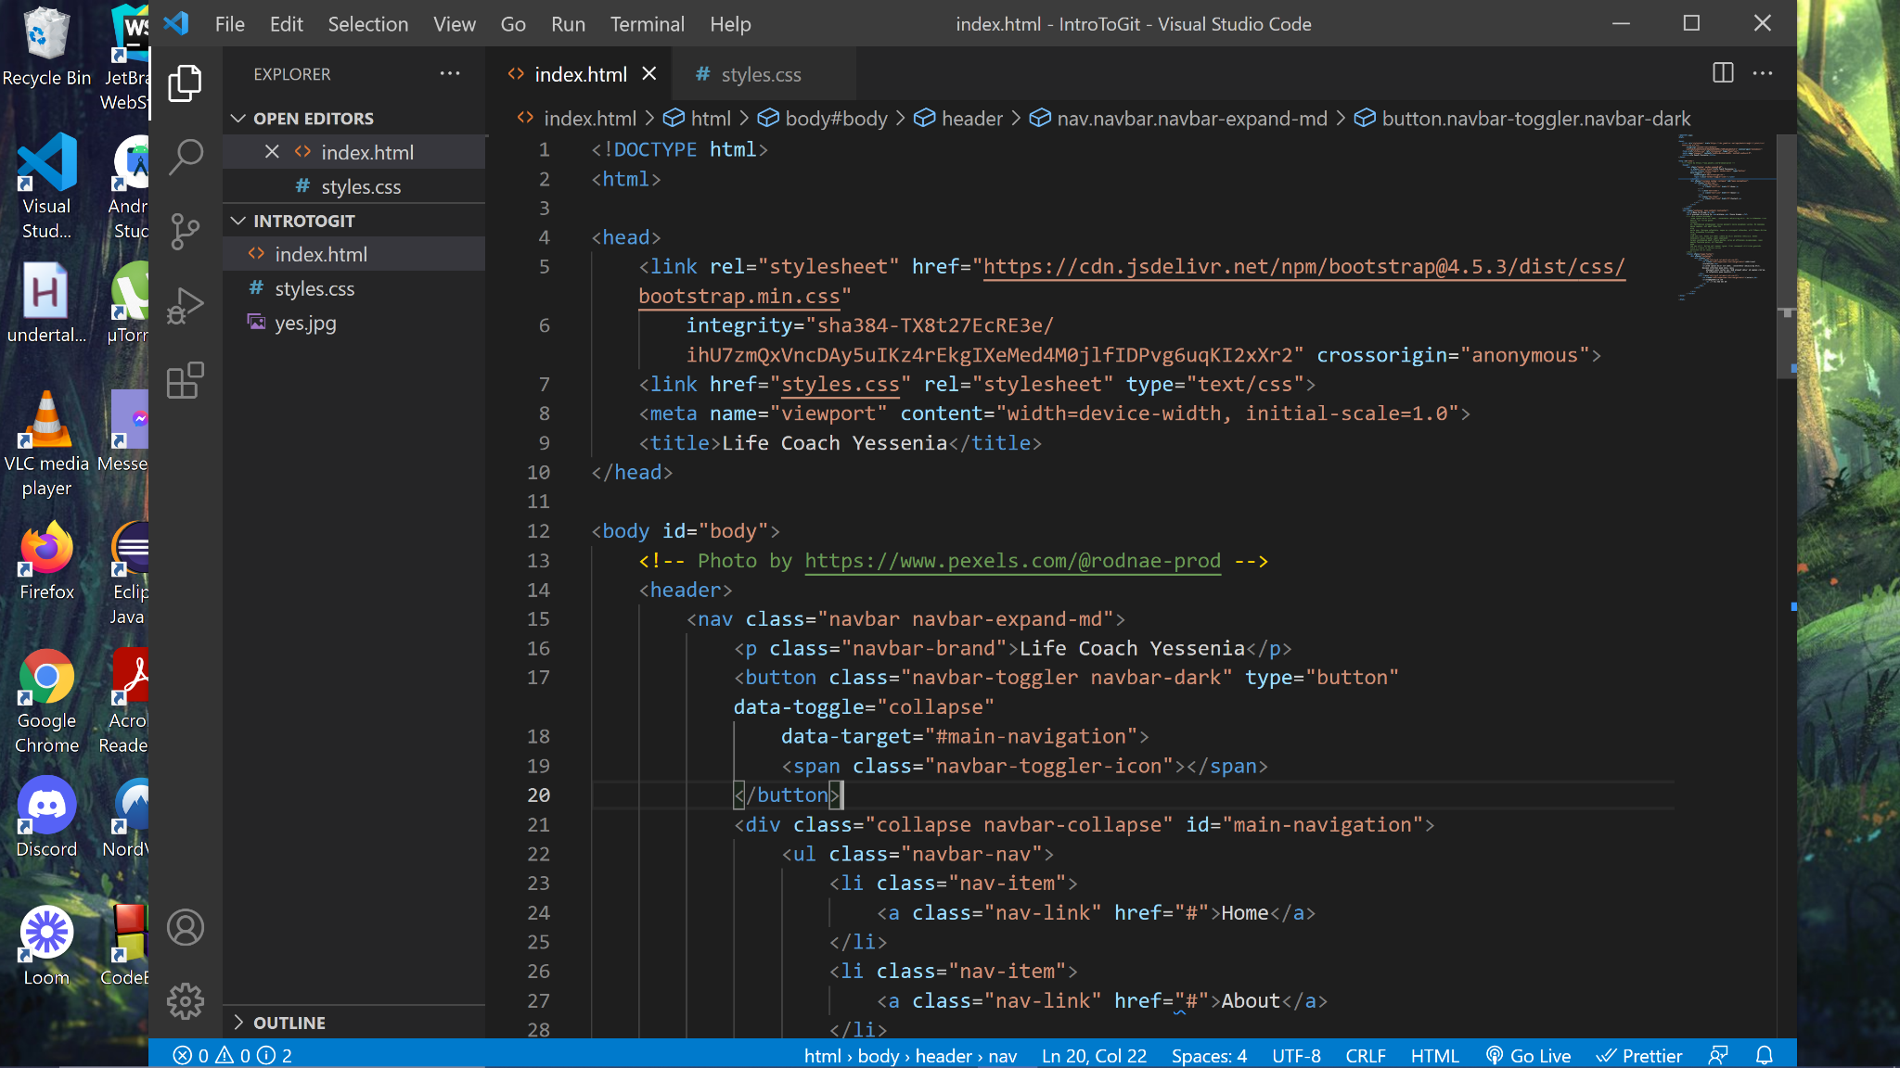

That’s it! Prereqs and starter code successfully acquired!



Thanks! See you at the workshop😊

-[Nia](https://www.instagram.com/niaapplications/)💜

*^DM me if you need help with any of this set up!*